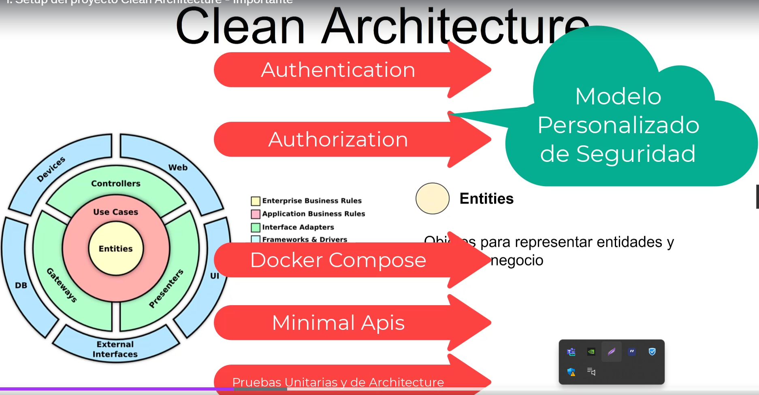

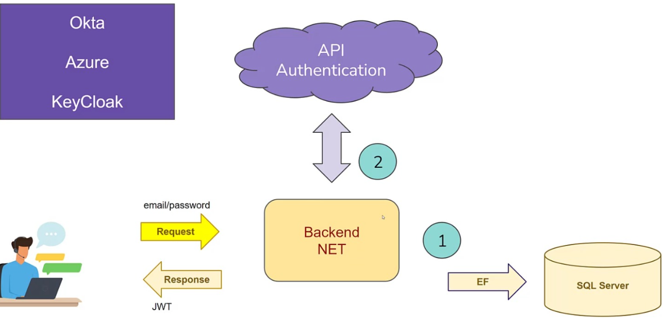

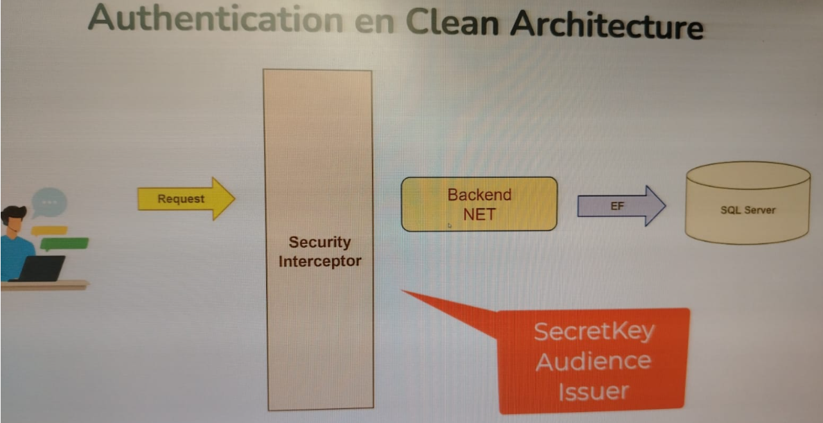

Enumerar ventajas de docker.

Como funciona docker?

* Docker engine.
* Docker desktop.
* Docker hub.
* Docker compose
* Kubernetes.

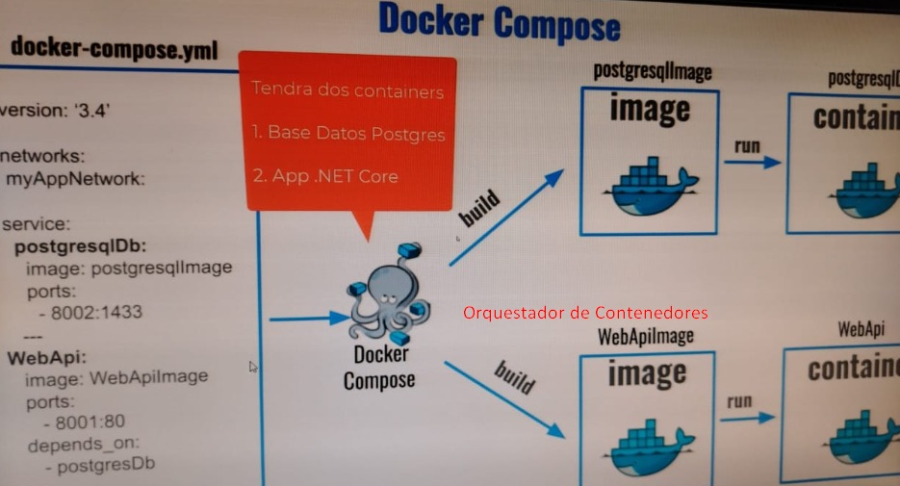

Archivo de configuracion de Docker

appsettings.Test.json

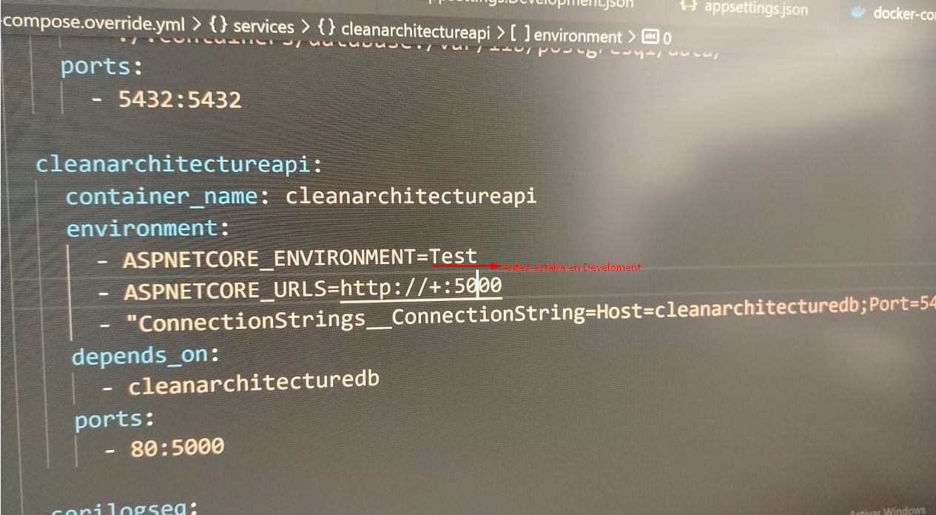

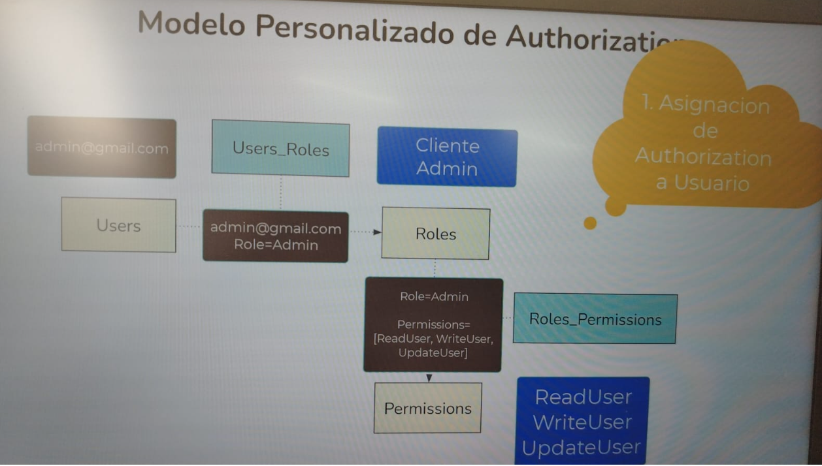

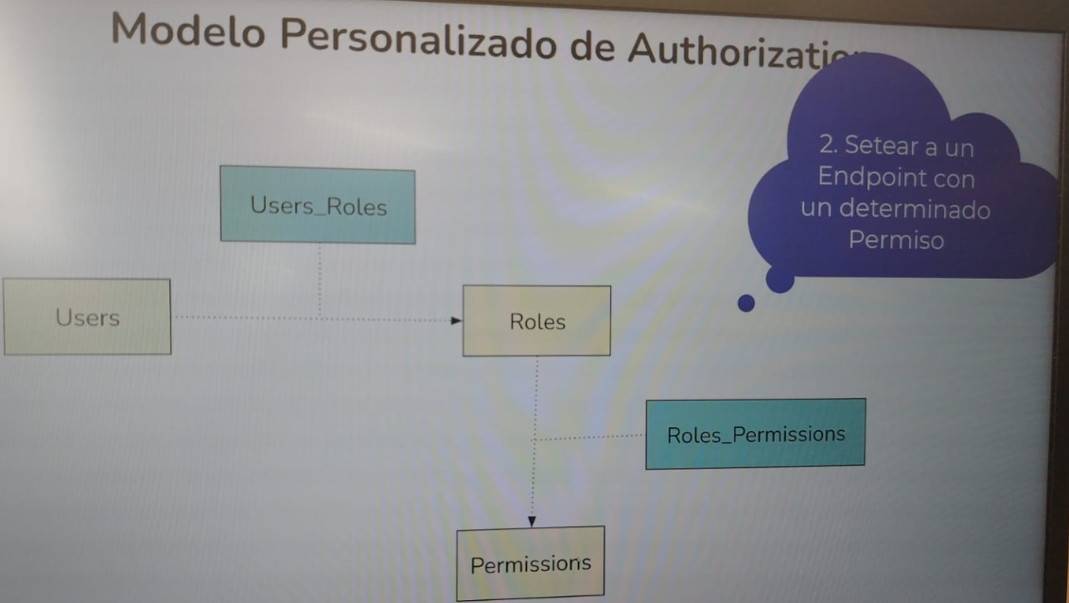

dotnet ef --verbose migrations add InitialCreate -p src/CleanArchitecture/CleanArchitecture.Infrastructure -s src/CleanArchitecture/CleanArchitecture.Api

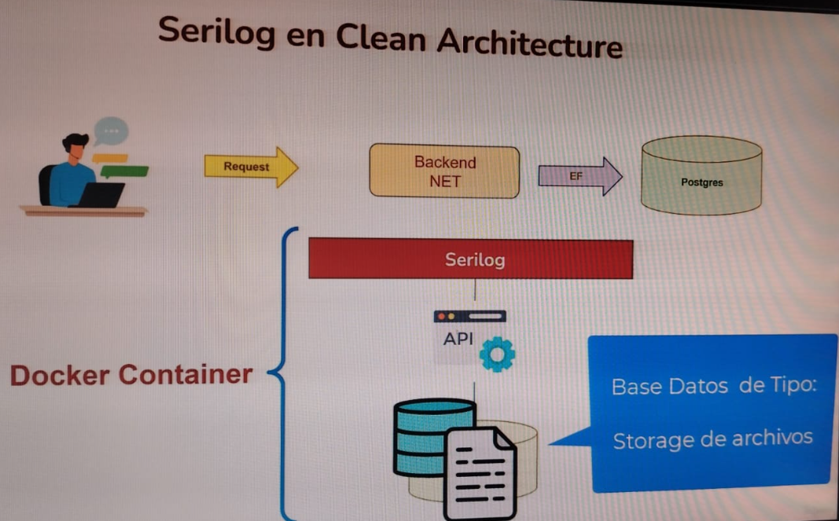

dotnet run --project src/CleanArchitecture/CleanArchitecture.Api

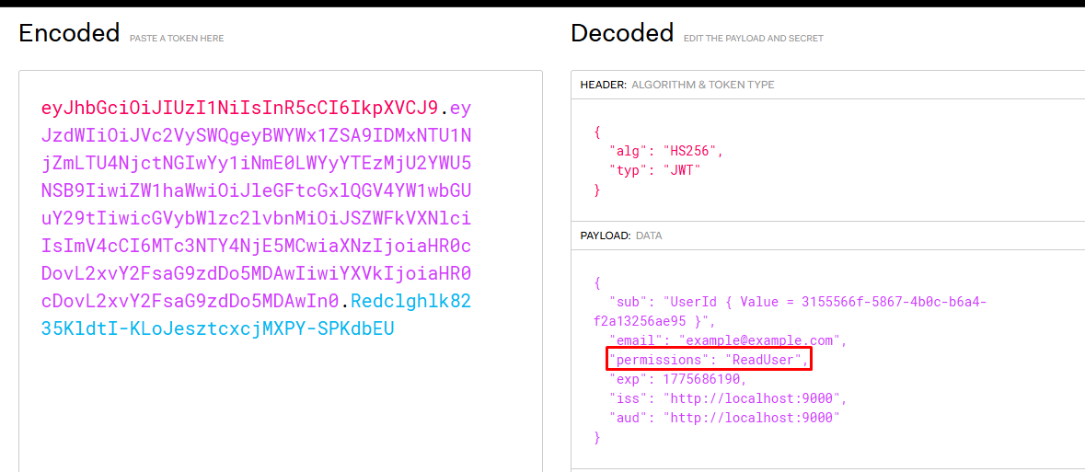

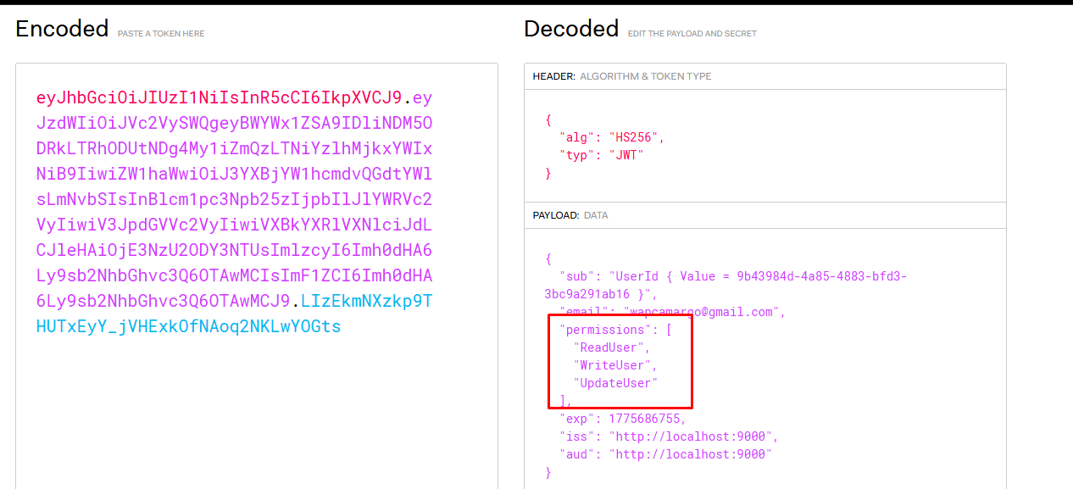

cross-cutting concern 🡺 preoccupation transversal

